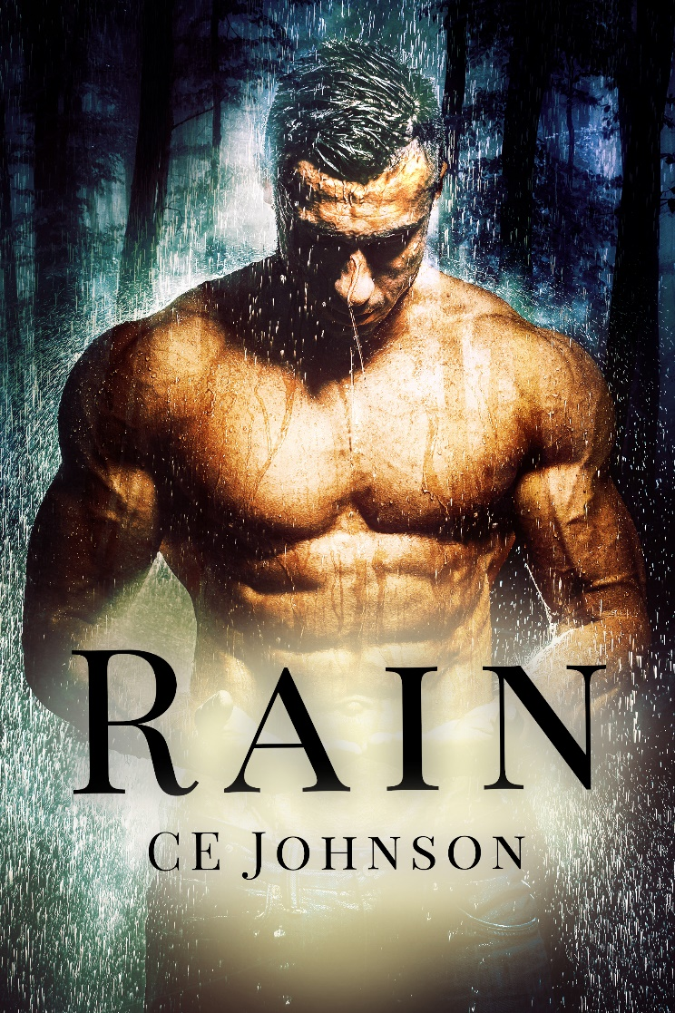

(Cover and additional graphics provided separately.)

Title: Rain
Author: C.E. Johnson
Genre: Contemporary Romance/ Romantic Suspense Standalone
Release Date: April 17, 2018

Blurb:
Charlie had it all.
Beauty. Brains. And the guy.
Until the perfect boyfriend went from heaven to hell.
Fearful for her life, and the sting of his hand still lingering on her cheek, she runs.
But she knows he won't let her go so easily.

Determined to leave his crime-ridden life behind, Rain retreated deep into the Oregon woods.
He has everything he needs.
A beautiful home and a life of solitude.
But when an injured woman staggers onto his property, he can't help but think she's part of an elaborate setup.
His gut says believe her.
His paranoia says trust no one.
His heart, however, is completely screwed.

Will enemies from both of their pasts ruin their chance at a future, or will love find a way?

Buy links: (Kindle Unlimited)
Amazon US: https://amzn.to/2HqfyLk
Amazon CA: https://amzn.to/2HjESCH
Amazon UK: https://amzn.to/2HlalEx
Amazon AU: https://amzn.to/2Hn1Gl4

Reviews:

“I am so in love with this book. It was suspenseful, beautiful and sexy... add some humor and you have one amazing story! I could go on all night about how incredible it is but instead I will just recommend this to everyone. Charlie and Rain’s story is one you don’t want to miss!” -Michelle, Goodreads Reviewer

“Rain is the first book that I've read by C.E. Johnson, and WOW! I LOVED every exciting & suspenseful minute of it! As I devoured it cover to cover in one sitting, I found her writing style to be both brilliant, and original.” -Jennifer, Goodreads Reviewer

Short Excerpt:

“What’s your name?” she asks.
“Rain.”
Curiosity fills her eyes, but she doesn’t ask anything else.
“Thank you,” she whispers as she puts her wrapped arm back at her side.
Sitting back in the chair, I nod and feel the pull from a muscle on one side of my cheek. Her eyes dip to my mouth, taking in the half smile that I didn’t mean to do. It disappears quickly as a loud knock on the door sends her flying out of the seat. I rise forcefully but steady until she collides with me. Ignoring the small woman against me, I grab my gun from the counter. Instead of leaping for the door for someone to rescue her from me, she latches onto my arm. Her grip is so tight that it could draw blood, and all I can think about is how amazing her touch feels against my skin. It takes me a minute to regain the fact that someone is at my fucking door. I look down to her long fingers begging for protection. For saving. It’s possible she’s a really good actress. But what if she isn’t and there is something truly evil torturing her? I don’t know what is wrong with her. But for the first time in years—and with no idea how I got to this point already—I give a fuck enough to find out.
Other novels by C.E. Johnson:

Done (In the Dark, #1)
Amazon US: http://amzn.to/2sku1Av
Amazon UK: https://goo.gl/kOVkwe
Amazon CA: https://goo.gl/FMjWOf
Amazon AU: https://goo.gl/6kZh3l
Goodreads: https://goo.gl/Epf2Oe

Just One (In the Dark, #2)
Amazon US: https://amzn.to/2JbEpjd
Amazon UK: https://amzn.to/2HHkuLM
Amazon CA: https://amzn.to/2vEsBUS
Amazon AU: https://amzn.to/2JaHbVG
Goodreads: https://goo.gl/58Aias

About the Author
C.E. Johnson is an author of contemporary and suspense romance novels. Her first novel Done (In the Dark Series, #1), released in May 2017.

When not writing until all hours of the night (with lots of late night coffee runs), she loves to read books that feature a strong male with a soft spot for his feisty heroine. She prefers stories that rip your heart out completely, then kindly place it back into your chest with a HEA.

She lives in a suburb of Chicago with her husband, two kids, and some spoiled rotten animals.

Social media links:
Facebook: @AuthorCEJohnson
Twitter: @AuthorCEJohnson
Instagram: AuthorCEJohnson
Goodreads: https://goo.gl/Neay37
Join C.E.’s Reading Roses reader group! https://goo.gl/uzZdhL

